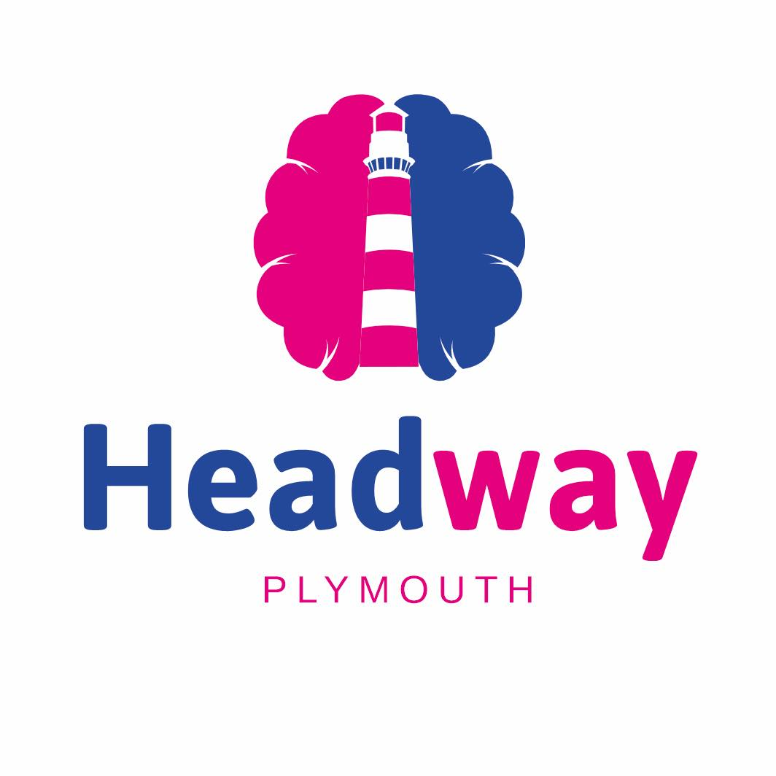

Trustee Recruitment Information Pack
June 2026

Contents
Welcome from our Chair and CEO
Vision / Mission / Values
About Headway Plymouth
The Trustee role and what we’re looking for
Meet our Trustees
Trustee Role Description
Trustee Code of Conduct

Welcome from the Chair of Headway Plymouth

Hello,
Thank you for showing an interest in Headway Plymouth – a small charity with HUGE ambition!
We want to provide you with some information about the charity and what becoming a Trustee means. This is an important decision, which has legal responsibilities. However, it is also hugely rewarding and can really help with your own personal development.
With our ambition, we not only want the charity to grow and thrive but we want our Trustees to grow and thrive too.
We need a broad set of skills on our Board: You could be helping:
- shape whether we have enough money to undertake the activities and support we want to provide;
- make sure we follow our policies and procedures;
- ensure Headway Plymouth run activities safely for our service users;
- check we're aligned with our values;
- help us develop partnerships to strengthen our work and communities;
- influence the future of the charity;
- make us work better together, develop skills, make friends and have fun!
In addition to reading the information contained in this pack, we recommend that you take time to find out more about the role and responsibilities of Trustees. You may fund the following link a useful starting point Become a charity trustee - GOV.UK
We would welcome your application by sending a CV and covering letter highlighting why you’d like to be a Trustee to ceo@headwayplymouth.org.uk
If you’d like to have an informal discussion or visit us, please contact us and we’d be delighted to meet with you. You might find it helpful to talk to one of our existing trustees.
If you have any questions, please do not hesitate to contact our office on 01752 550559 or email our CEO Craig Butler at ceo@headwayplymouth.org.uk

Rob Antrobus
on behalf of Headway Plymouth Board of Trustees

Welcome from the CEO of Headway Plymouth
I have worked with Headway Plymouth for well over two years – guiding it through a huge process of transition and growth. It’s been an exciting, fantastic and, frequently scary, journey. I have learned so much and have so much still to learn.
One thing that has been apparent throughout is that a strong and effective Headway Plymouth is built on the breadth of knowledge and perspective guiding it. Our trustees’ mixed skills are one of our greatest strengths.
The board of Headway Plymouth brings together individuals with experience in fundraising, healthcare, finance, governance, commissioning, and community engagement. This allows us to challenge assumptions, make balanced decisions, whilst remaining accountable to the people we serve. Their varied expertise helps us identify emerging opportunities, manage risk responsibly, and ensure that every pound entrusted to Headway Plymouth delivers meaningful impact for ABI survivors and their families.
Brain injury rehabilitation is also complex and deeply personal work; it demands both compassion and rigorous oversight. A diverse board ensures that innovation is grounded in realism, and ambition is matched with sustainability.
As our board of trustees changes and grows we seek to add strength in depth around lived experience, greater financial oversight, business collaborators, and those skilled in various forms of media, communications and IT.
Looking ahead, our charity aims to expand access to specialist rehabilitation, strengthen partnerships with local services, grant foundations and corporate sponsors.
Through these routes to income generation and more traditional fundraising approaches (we love fundraising challenges, events and a quiz) we will be far better placed to invest in preventative and community-based support – whilst continuing to offer an ever more dynamic social, activity, education and peer support led space in our centre hub.
This year will see the further development of our garden space, new projects around justice and supporting women with ABI and wider education and support for families and carers.
By combining strategic governance with compassionate leadership, we will continue to grow sustainably, while remaining focused on improving independence, confidence, and quality of life for those affected by brain injury.
We’d be delighted to talk to you about our work and becoming a Trustee – so do get in touch!
Craig Butler
CEO of Headway Plymouth

Our Vision, Mission and Values
- Our Vision
Is for all individuals, their families and carers affected by acquired brain injury to have access to all the support they need to maximise their potential.
- Our Mission:
Headway Plymouth’s mission is to enable those with an acquired brain injury and their families and carers to live independent lives.
- Our Values:
Devised in 2025 by staff, trustees and clients, these values underpin everything we do and how we act – as individuals and as a charity:
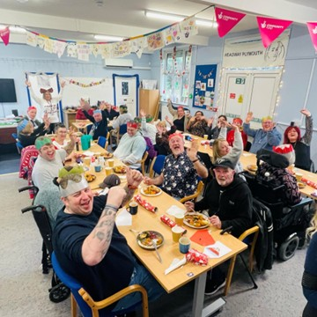
We Are:
KIND
Creating a safe space and treating everyone with dignity, empathy and respect.
EMPOWERING
Enabling people to rebuild their lives, promoting confidence, independence, and well-being.
INCLUSIVE
Welcoming everyone without discrimination.
COLLABORATIVE
Working in partnership with others to provide the best possible support.
PASSIONATE
To use and develop our skills to improve people’s lives.

About Headway Plymouth
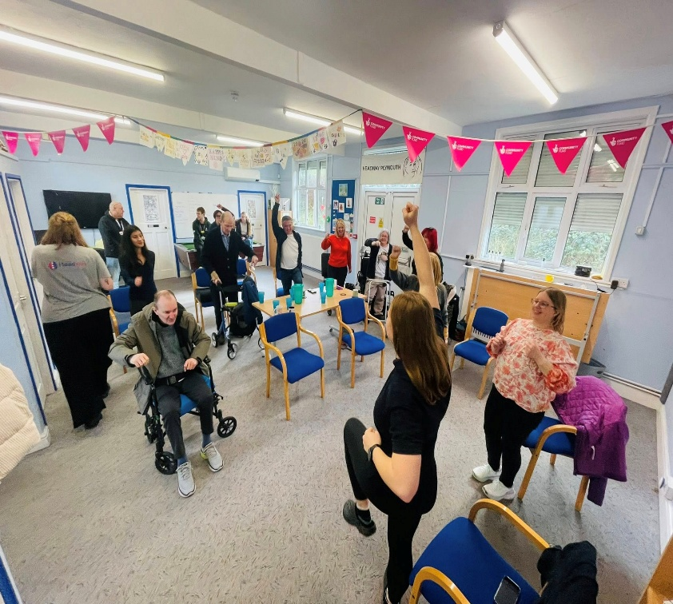
"I love going to Headway as it’s a place with no judgement. You can be yourself and it's lovely to be around other people who understand".
"Thanks to your team. I learned so much last week, and I want you to know what a wonderful, bubbly, fun team you have there. You all made me feel incredibly welcome and comfortable, especially with your clients, who are also such an inspirational bunch".
"I just wanted to thank you all for your words of encouragement yesterday. I’m feeling so much more positive about things today, I thought I would send you all an email in case I forget to thank you all"
Originally formed in 1989, Headway Plymouth is an independent charity affiliated to (but completely separate from) Headway – The Brain Injury Association. Since 1997 Headway Plymouth has occupied the same centre-based hub in Devonport Park, Plymouth.
The charity supports adults of all ages living with an Acquired Brain Injury (ABI) - as well as their families, carers and the professionals who, in turn, care for them.
Headway Plymouth supports all forms of ABI including Traumatic Brain Injuries (from falls, collisions, assaults etc) to all medical brain injuries (including stroke, tumour, infection, hypoxia and neuro-toxic injuries).
In 2023 the charity began a journey of transformation delivering new services in the centre and the community. We built new relationships with Health, Adult Social Care and VCFSE partners across Plymouth. We developed new funding streams working with grant-making foundations and corporate sponsors, and we are still working to develop new Health/ICB and Adult Social Care commissioned projects and well as growing a loyal donor base, charity champions, volunteers and fundraisers.
As well as updating our building to present a bright and welcoming space to clients and families, we have vastly diversified our range of activities, education and peer support. We have also established our highly successful (and flatteringly copied!) hospital liaison project and developed a 1:1 community outreach and enablement service. Across these services, we now support hundreds of clients and families in Plymouth and the surrounding area in hospital, across discharge home, in their communities and in our vibrant centre hub.
The Trustee role and what we’re looking for
We are looking for 2 or 3 brilliant new Trustees who can bring their skills, experience and enthusiasm to Headway Plymouth as we take the charity forward. They will join our existing Board of 5 Trustees, who share a common passion for supporting individuals with an ABI, and who are welcoming and supportive of each other.
We are guided by a simple vision: for all individuals, their families and carers affected by acquired brain injury to have access to all the support they need to maximise their potential.
We are open to applicants with a wide range of skills and backgrounds and welcome discussions about what you could bring to the charity. We are particularly interested in people who can bring any of the following:
- Expertise and experience in working in the NHS, both in clinical and managerial roles
- Expertise in brain injury within the NHS; particularly leadership or commissioning services
- Experience and skills in digital, marketing and comms
- Project management, business experience and partnership development
- Fundraising and the charitable sector
This is an unpaid voluntary role. Reasonable expenses can be reimbursed on request. Trustees retire by rotation (longest standing to newest each year) but can be re-elected to post.
The Board of Trustees normally meets six times a year, this is usually online with a face-to-face strategy day early in the year. In addition, Trustees are encouraged to take on a specialist responsibility and support the CEO and staff where they can.
Further information on the role of a Trustee is available from Gov.uk The essential trustee: what you need to know, what you need to do - GOV.UK
What you can expect in return
We hope you will find being a Trustee rewarding and interesting, providing opportunities to develop your own experience and expertise. You will also benefit from:
- A comprehensive programme of training and development offered by Headway UK for all our staff and Trustees
- An opportunity to learn about brain injuries and their impact from our clients
- Taking part in strategic decision making
- Being part of a charity which has an ambition to grow and enhance services
- A role with meaning and purpose which will contribute to your own personal and professional development
- Support from a group of people with varied backgrounds but common goals as Trustees. You will be welcomed, included and valued.

Meet our Trustees!
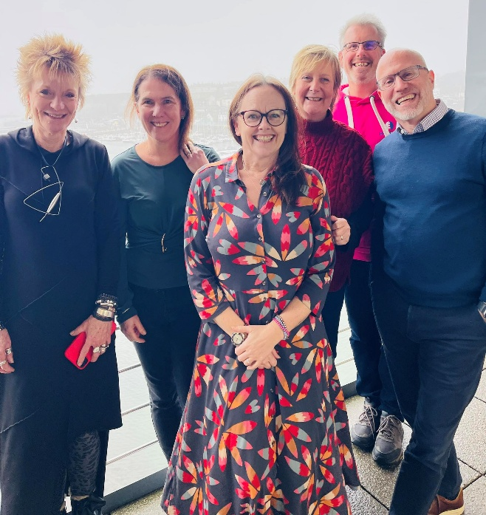
We are friendly, welcoming and can’t wait to meet you!
Rob Antrobus – Chair
I am a Partner at a large national law firm which has an office here in Plymouth. My day job involves supporting those who have suffered a brain injury navigate the complexities of the legal system.
I also have a lived experience as my wife suffered a significant brain injury following a stroke in 2020. I therefore know the impact that a brain injury can have both on the individual and their wider network.
What do I love about being a Trustee and Chair?
Good question! Being a Trustee, which I have been for far too many years to mention, has been hugely rewarding. We've had challenges; however, we have also had some really positive times. Seeing the charity develop and grow is a real privilege. All this in an environment which is fun!
Hilary Dicks – Vice Chair / Trustee
Why I chose Headway Plymouth?
I previously served as CEO of another Headway group in the South West for five years. Alongside this, I also bring lived experience. My son sustained a serious brain injury at the age of eight, over 22 years ago. I first became involved with Headway Plymouth in 2019, working as a consultant. From the outset, I was struck by the genuine commitment, compassion and dedication of the staff and volunteers. It was clear that everyone shared a common goal: to deliver services that truly respond to the needs of the people who use them. That strong values-led culture made becoming a Trustee a very natural next step.
What I love about being a Trustee at Headway Plymouth?
I have been a Trustee for three years and currently serve as Vice Chair. One of the things I value most about our Board is the open, inclusive and supportive way we work together. We actively welcome new ideas and are always keen to strengthen the Board by bringing in people with different skills, backgrounds and perspectives. It’s incredibly rewarding to be part of a friendly, respectful team where everyone is united by a shared commitment to improving the lives of people affected by brain injury.
Karen Walker
Why I chose Headway?
On a personal level, I know first-hand what a difference a charity like Headway can make. My cousin, Neil, suffered a brain injury following an accident at work in 1989. It had a devastating effect on the whole family. Headway has helped Neil to come to terms with his disability and has provided him and his parents with strategies that have enabled him to live with the long-term effects of brain injury. Neil still attends Headway Plymouth nearly 40 years after his accident.
What I love about being a Trustee at Headway Plymouth?
I became a Trustee in 2014 and it was something I was immediately drawn to as I felt that I could give something back to the charity which had been a big part of my family over many years. I have learnt such a lot during my time as a trustee, particularly gaining an insight into how charities are run in terms of decision-making, governance, risk etc. I enjoy working as part of a team with my fellow Trustees; working towards the same mission to help survivors regain independence and improve their quality of life.
Anita Pascoe
Why I chose Headway Plymouth?
Acquired brain injury rehabilitation and support is my absolute passion and I happen to have both work and personal experience of ABI. I am also an enthusiastic Plymothian and Headway Plymouth was an easy marriage of the two.
What I love about being a Trustee at Headway Plymouth?
When I visited late last year, I posted this - says it all really!
Popped into Headway Plymouth today and caught up with CEO Craig Butler , unit manager Pete and the incredible team there. As an occupational therapist, it was especially heart-warming to see the centre filled with people engaged in purposeful activity- sun catchers being made, beautifully refurbished kitchen emanating the smell of frying peppers and tomatoes, and everyone bright, happy and busy.
Staff, volunteers, service users and a work prep. student all working with a common purpose. What a great charity this is-living out its mission and values in all it does.
Inclusive, Kind, Empowering, Collaborative, Passionate about support for people living with brain injury in and around Plymouth.
Allice Hocking
Why I chose Headway
I’m from Plymouth and my sister introduced me to Headway Plymouth as she thought I’d enjoy working with them. I have several friends and family members who have had an ABI and felt an instant affinity with the charity. I volunteered for about 6 months and helped with bid writing and was delighted when the opportunity arose to become a Trustee.
What I love about being a Trustee at Headway Plymouth
I’ve been a Trustee for just over a year and really enjoy working with our CEO and the other Trustees. They are a great team and made me really welcome. I enjoy being able to make a difference and use my skills in such a positive way, it’s very rewarding. I’ve also made the most of the Headway training for Trustees and attended lots of online workshops from ‘Strategic Thinking’ to ‘AI and charities’. I love popping over to the centre and meeting our clients, usually there is cake on offer which is always a bonus!

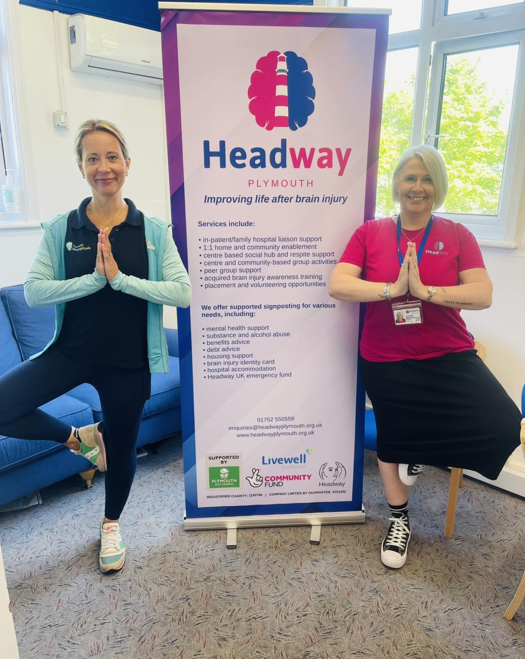

Role Title: Trustee Headway Plymouth
Direct Report: Works closely with the Chair, Chief Executive and other Trustees.

Main Responsibilities
Our governing document, the Articles of Association, set out the formal duties and responsibilities of the Trustees. As a Trustee, the Board is responsible for the overall governance and strategic direction of the charity, developing the charity’s aims, objectives and goals in accordance with the governing document and legal & regulatory guidelines.
General Duties and Responsibilities
1. To give time to the administration of the charity and take an active part in
running it

2. To contribute actively to the Board of Trustees’ role of giving a strong
strategic direction to the organisation, setting overall policy, developing goals
and evaluating performance

3. To help protect the property and interests of the charity

4. To safeguard the good name and values of the charity

5. To be aware of the charity’s financial position and ensure the financial
stability of the charity

6. To act reasonably, prudently and in the best interests of the charity in all
matters at all times

7. To ensure that all necessary statutory documents are returned to Companies
House and the Charity Commission on time

8. To abide by the Headway Plymouth policies and procedures at all times

9. To attend and contribute to all Board meetings

10. To attend, as best as possible, Headway Plymouth events, throughout the year

11. To represent and champion Headway Plymouth by being an ambassador and actively promoting the charity amongst target audiences

12. Maintain good relations with the staff and volunteers

Personal Specification
- Genuinely interested in the vision and mission of the charity with a commitment to enabling people impacted by acquired brain injury
- Expertise in a field of work/area of interest relevant to the continued success of the charity
- Willing to devote time and effort
- Strategic vision, good & independent judgement
- Respectful of the nature of collective decision-making while contributing their own viewpoint
- Understanding and acceptance of legal duties, responsibilities and liabilities of Trusteeship
- Dedicated to the organisation’s cause and objectives and willing to act as the charity’s ambassador to external bodies, charities and companies
- A team-oriented approach to problem solving and to management.

Time Commitment / Location
- The Board meets six times a year, with most being online and with one strategic meeting held in person in Plymouth

HEADWAY BOARD OF TRUSTEES’ CODES OF CONDUCT
As a trustee of Headway Plymouth, I promise to abide by the fundamental values that underpin all the activity of this organisation. These are:
A Accountability
Everything HEADWAY does will be able to stand the test of scrutiny by the public, the media, charity regulators, members, stakeholders, funders, Parliament and the courts.
B Integrity and honesty
These will be the hallmarks of all conduct when dealing with colleagues within VOLORG and equally when dealing with individuals and institutions outside it.
C Transparency
HEADWAY strives to maintain an atmosphere of openness throughout the organisation to promote confidence of the public, stakeholders, staff, charity regulators and Parliament.
Additionally, I agree to the following:
1 Law, mission, policies
1.1 I will not break the law or go against charity regulations in any aspect of my role of trustee.
1.2 I am not disqualified by law from acting as a charity trustee or a company director and I will sign an annual declaration that I continue to be eligible to act as a trustee
1.2 I will support the mission and consider myself its guardian.
1.3 I will abide by organisational policies.
2 Conflicts of interest
2.1 I will always strive to act in the best interests of the organisation.
2.2 I will declare any conflict of interest, or any circumstance that might be viewed by others as a conflict of interest, as soon as it arises.
2.3 I will submit to the judgment of the board and do as it requires regarding potential conflicts of interest.
3 Person to person
3.1 I will not break the law, go against charity regulations or act in disregard of organisational policies in my relationships with fellow trustees, staff, volunteers, members, service recipients, contractors or anyone I come into contact with in my role as trustee.
3.2 I will strive to establish respectful, collegial and courteous relationships with all I come into contact with in my role as trustee.
4. Protecting the organisation's reputation
4.1 I will not speak as a trustee of this organisation to the media or in a public forum without the prior knowledge and approval of the CEO or Chair.
4.2 When prior consent has not been obtained, I will inform the Chair or Project Co-ordinator at once when I have spoken as a trustee of this organisation to the media or in a public forum.
4.3 When I am speaking as a trustee of this organisation, my comments will reflect current organisational policy even when these do not agree with my personal views.
4.4 When speaking as a private citizen I will strive to uphold the reputation of the organisation and those who work in it.
4.5 I will respect organisational, board and individual confidentiality.
4.6 I will take an active interest in the organisation's public image, noting news articles, books, television programmes and the like about the organisation, about similar organisations or about important issues for the organisation.
5. Personal gain
5.1 I will not personally gain materially or financially from my role as trustee, nor will I permit others to do so as a result of my actions or negligence.
5.2 I will document expenses and seek reimbursement according to procedure.
5.3 I will not accept substantial gifts or hospitality without prior consent of the Board.
5.4 I will use organisational resources responsibly, when authorised, in accordance with procedure.
6. In the boardroom
6.1 I will strive to embody the principles of leadership in all my actions and live up to the trust placed in me by (organisation).
6.2 I will abide by board governance procedures and practices.
6.3 I will strive to attend all board meetings, giving apologies ahead of time to the Chair if unable to attend.
6.4 I will study the agenda and other information sent me in good time prior to the meeting and be prepared to debate and vote on agenda items during the meeting.
6.5 I will honour the authority of the Chair and respect his or her role as meeting leader.
6.6 I will engage in debate and voting in meetings according to procedure, maintaining a respectful attitude toward the opinions of others while making my voice heard.
6.7 I will accept a majority board vote on an issue as decisive and final.
6.8 I will maintain confidentiality about what goes on in the boardroom unless authorised by the Chair or board to speak of it.
7. Enhancing governance
7.1 I will participate in induction, training and development activities for trustees.
7.2 I will continually seek ways to improve board governance practice.
7.3 I will strive to identify good candidates for trusteeship and appoint new trustees on the basis of merit.
7.4 I will support the Chair in his/her efforts to improve his/her leadership skills.
7.5 I will support the CEO in his/her executive role and, with my fellow board members, seek development opportunities for him/her.
8. Leaving the board
8.1 I understand that substantial breach of any part of this code may result in my removal from the trustee board.
8.3 Should I resign from the board I will inform the Chair in advance in writing, stating my reasons for resigning. Additionally, I will participate in an exit interview.

